Name : ………………………………………….
Address: ………………………………………….
………………………………………….
Date: ………………………………………….
Time: …………………Food Time…………………..
Room Hired: ………………………………………….
INVOICE No: 2017/
MEETING
SEMINARS & FUNCTIONS

Let Us Cater For All Your Needs.

Our services include everything from Coffee on arrival, mid-morning
break with Danish pastries, to full buffet or meal service.

The choice is yours and limitless!

Below is our standard selection to help you refuel during breaks.
Please see our buffet menu for lunchtimes or contact our catering manager.

 |  | On Arrival  __:__am | AM Break  __:__am | Lunch  __:__pm | PM Break  __:__pm
Item |  | Quantity | Quantity | Quantity | Quantity | Total Qty | £ P/Person | Total£
Tea & Coffee |  |  |  |  |  |  | 0.90p
Orange & Apple Juice |  |  |  |  |  |  | 0.90p
Mineral Water |  |  |  |  |  |  | £1.20p
Fresh Iced Water |  |  |  |  |  |  | 1.00 per jug  (8 servings)
Biscuit Selection |  |  |  |  |  |  | 0.65p
Mini Danish Selection |  |  |  |  |  |  | £1.35p
Doughnut Selection |  |  |  |  |  |  | £1.50p
Croissants Butter & Jam |  |  |  |  |  |  | £1.75p
Bacon Baguettes | 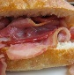 |  |  |  |  |  | £2.95
Fresh fruit Selection  min 20 |  |  |  |  |  |  | £18.95(20)  +0.85pp thereafter
 |  |  |  |  |  |  | TOTAL | £
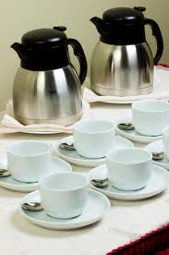

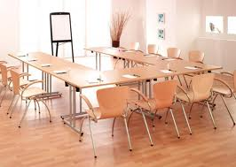
HIGH CROSS CAFÉ is operated by:
KEELEY CONTRACT CATERING
01276-61961~ 07544-850122
info@high-cross-cafe.co.uk info@keeley-catering.co.uk

Final Total: £…………….
Notes:………………………………………………………………………………………………………………………………………………………………

