

**Name** : ………………………………………….

**Address**: ………………………………………….

………………………………………….

**Date**: ………………………………………….

**Time**: …………………**Food Time**…………………..

**Room Hired:** ………………………………………….

**INVOICE No: 2017/**

***Finger Buffet Menu 2017 (min 20)***

**Menu A**

**Selection of:** Filled Finger Rolls

Topped French Baguettes

**Plus 4 savoury items £6.95 *per person***

**~~~**

**Menu B**

**Selection of:**  Filled Finger Rolls

Topped French Baguettes

**Plus 6 savoury items £8.95 *per person***

**~~~**

**Menu C**

**Selection of:** Filled Finger Rolls

Topped French Baguettes

**Plus 8 savoury items £10.95 *per person***

***~~~***

**Choose From:**

|  |  |  |  |
| --- | --- | --- | --- |
| **Sausage Rolls** |  | **Tortilla Wraps** |  |
| **Vol-au-Vents** |  | **Mixed &Stuffed Olives** |  |
| **Pizza Slices** |  | **Mini Spring Rolls** |  |
| **Cheese & Pineapple** |  | **Prawns in Filo** |  |
| **Cocktail Sausages** |  | **Butterfly Prawns** |  |
| **Chicken Goujons** |  | **Quiche** |  |
| **Garlic Mushrooms** |  | **Crisps & tortilla Chips,** |  |
| **Samosas** |  | **Chicken Wings** |  |
| **Savoury Eggs** |  | **Salad Sticks & Dip** |  |
| **Mini Pork Pies** |  | **Stuffed Jalapenos** |  |

**X £6.95 =£**  .

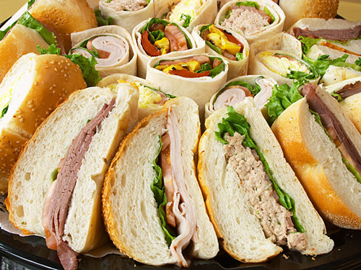



**X £2.25 =£** .

**X £2.95 =£** .

**Mixed Sandwich Patters Are Available at**

***£2.95 per person for 1-19people***

***Or £2.25 per person for min of 20 people***

*Total Cost: £……………*

*Notes:…………………………………………………………………………………………………………………………….*

**Alternative Are Available, Please Ask for Further Details.**

HIGH CROSS CAFÉ is operated by: KEELEY CONTRACT CATERING 01276-61961~ 07544-850122

[info@high-cross-cafe.co.uk](mailto:info@high-cross-cafe.co.uk) [info@keeley-catering.co.uk](mailto:info@keeley-catering.co.uk)

**X £10.95 =£** .

**X £8.95 =£** .

